**GENERIC TO BRANDED MEDICINE**

ASHISH SANGHVI (13BCE0852)

ARIHANT SINHA (13BCE0167)

School of Computing Sciences,

Vellore Institute of Technology

**ABSTRACT**

The aim of the project is to increase the user knowledge and awareness through peer to peer reviews and collection of real time data about composition, side-effects of various drugs, tablets and other dietary products from different trusted websites. It gives the user a chance to understand the composition, side-effects and harms that a particular drug can cause but not substitute the doctor’s advice. The project makes use of the most reputed medical websites and has multiple databases to store this data. Against each medicine its market share, minimum age, dosage requirements, side-effects, chemical composition, rating and reviews will be stored. The greater the no of patients the more accurate the data will be. This project uses the principle of open platform for rating and reviews medicines for basic and small illness and not major diseases where doctor’s advice is the best.

**KEYWORDS**

Peer-to-Peer Review, Web-Based application, Real time System, Customer Database, Side-Effects

1. **INTRODUCTION**

Have you ever asked your friends who live in different vicinity which medicine they take for fever, for example? You will notice that we ask this question for mobile phones, food products but rarely for medicines. Generally we rely heavily on the Doctor’s advice or pharmeutical’s advice. This software hopes to solve this problem. It implements an open rating platform where the patients can enter their experience and the side-effects of different medicine for the same illness or same generic type. While doing this, the software also details the chemical composition of all variations and their market share to enable the patient to make the best possible choice.

This software implements the tasks by storing the different medicine’s chemical composition retrieved from different websites in a database. The patient’s age and weight are taken into consideration before advising him with the options. The database is made from the suggested side-effects seen by the patient in the other portal used for sharing user’s experience.

The user is provided with options to fill reviews referring to side-effects, effectiveness etc. which is then stored in the database. The user can also rate the medicine and provide a review. This all is stored in a database and retrieved when the patient asks for advice.

The sales records, chemical composition are generated in the form of a pie chart for giving a relatively easier viewing and understanding to the user who might be illiterate. This pie charts for various medicines is given which helps the user decide what decision are to be taken under various conditions.

Suppose the user is allergic to a certain type of chemical the user can view the chemical composition of various medicines and decide for a relatively safer medicine amongst the given list of medicines. The User can use this platform to raise his voice and concern about the various medicine and brands and thus pitch his/her grievances in various cases for the medicines. Thus the platform becomes a benchmark of the transparency of the drug use.

The user review can be put in the form of a Patient, NUTRITIONALISTand Doctor. So the user can know in relation to what the user is putting forward his experience and advice and also helps keeping a track of the authenticity of the advice.

This project aims to help patients find the right branded medicine for a generic medicine through an open rating platform. The patients once they make the required choice using the platform can add their experience for improving the platform. This will allow for free and fair comparison of medicines based on experience of the patients. This software will not be responsible for any suggested side-effects as the patients might not be well- illiterate in medicines. The project uses website as front end and Excel sheets, R programming and Databases for back-end. We provide the patient with two portals (review, suggestion) one to take advice and another to share his experience. The other data this project gives will be of chemical composition of each branded version and the market share of the required branded medicines taken for reputed websites.

1. **RELATED WORKS**

The concept of peer-to-peer owes its origin to crowdsourcing and Internet which created the idea of “knowledge of the mob”. The idea of peer-to-peer patient reviews for medicine largely derived from its origin to peer-to-peer review of medical articles and journals by medical personal. A lot of research has been done in analyzing the value and relevance of peer-to-peer reviews in the field of medicines. The usability and credibility of peer reviews for medical papers has been divided with some concluding it as useful others as irrelevant [6]*.* Smith R. Peer has concluded the peer review system for medical papers was a revolution only if it can be utilized with restraints and controls to prevent abuse which it very ease on peer review platforms [5]*.* Spier R proves that that the traditional system of publishing is unfair and implementing a peer review system is needed but with some modification [3].

After applying peer review for papers it has been applied for quality of care at different hospitals and clinics. The issue of credibility of peer reviews is being question by different research. Goldman RL concluded after analysis and comparison that some reviews changed even if the situation was repeated rising serious doubts about the credibility of peer review systems [2].The major difference of medical and engineering is that patients in the field of medicines is little and of very little use compared to engineering products where the customer it best placed to decide which products are useful. This has been the major hindrance in growth of this work. Lot of research has criticized the lack of credibility of peer reviews in this field. A technology solution to check and removed unreasonable reviews could be found. One of the solutions could be follow sites like stack overflow where set of qualified doctors could remove unreasonable reviews. One of the other solutions discussed by Spier R is international policing to prevent abuse and not allow anonymous reviews [3].

The idea of project also is based on the fact that most of the people ask the pharmacy about which drug should they take for non-fatal illness. These pharmacy are called community pharmacy where the pharmacist uses this local knowledge and experience to suggest the medicine. This project envisions a creation of global community pharmacy. A lot of research on advantages and disadvantages and how can community pharmacy be extended has been done. American Pharmacists Association has recently analyzed its huge data to compare the doctors and pharmacy suggestion and conclude that in almost all cases of non-fatal common illness the pharmacy was in agreement with the doctor’s.[7]

After success in reviewing most other products, this peer review system has still not found its place in medicine. This is largely because of three reasons. Firstly, if multiple medicines of a single illness exist then mostly there exists a generic drug which is promoted at the cost of branded medicines for obvious reason of reducing cost. Secondly, the knowledge of patients in the field of medicines is little and of very little use. Also the reviews are wrong and, at times, dangerous. This is a research issue with scientific opinion split as already discussed above. Thirdly, this system is prone to abuse and it’s difficult to prevent abuse when the user is anonymous and global. However, with some compromise and technical adjustments, if possible policing, we can make this project work

1. **GENERIC TO BRAND SYSTEM ARCHITECTURE**

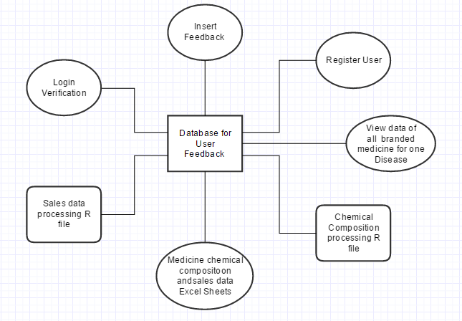

Fig1: The repository based architecture diagram for the project.

The architecture shows that we have two portals for users. The feedback portal provides the user with the ability to share his experience in form of side-effects of the medicine and rate and write a review for the particular medicine. The Suggestions & Advice portal provides the user with chemical composition, market share, rating and suggested side-effects of the medicine which are most commonly referred by users.

Both the portals are connected to the database management software. The suggestions portal only makes queries to the database, while the feedback manipulates the data in database. The feedback portal adds the user reviews, suggested side-effects and rating to the database against the medicine.

The databases take chemical composition of the medicine from reputed websites. Each database contains a set of medicines and data for this obtained from the websites. Each website may only contain some medicines hence we need multiple databases.

1. **FRONT END DESIGN**

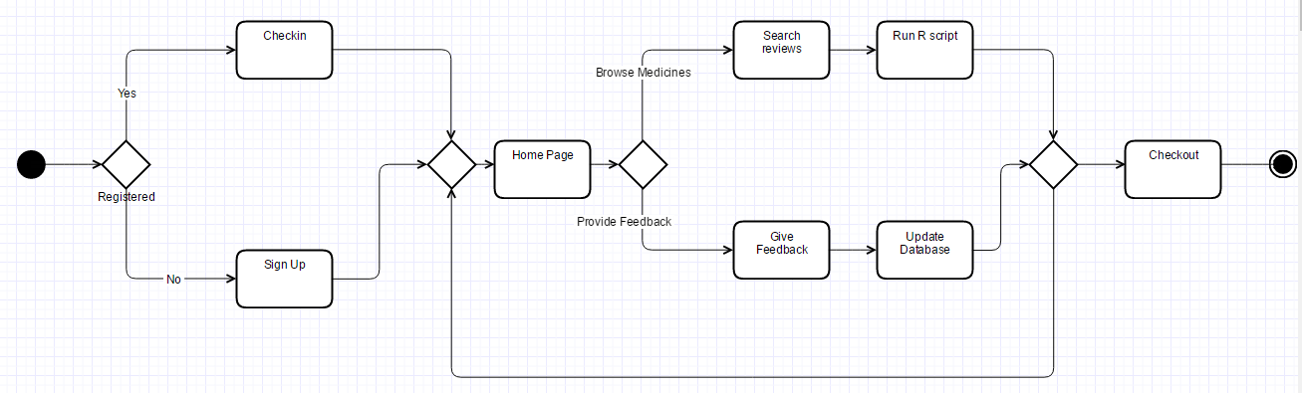

Fig2: The activity diagram for User of our website and backend activities.

First webpage asks the user to signup if he is and yet sign up else he is asked to login. After login, he is provided with the option of browsing medicines or giving feedback. If the user uses to browse for medicine the Suggestions portal is opened. For this webpage the content about the medicine is taken from database and r script is dynamically run on the data to produce real-time pie chart of market shares.

If the user chooses to provide a feedback then the feedback portal opens. After the user chooses the illness he is supplied with a list of medicines. After he/she chooses the medicine and provides feedback for it the database is updated. Now if the user wants to check out he can choose to or else he can return to the home page.

1. **METHODOLOGY**

We use databases to store review by patients, nutritionists and doctors and webpages for getting users inputs about the medicine, accept user’s request for advice and reputed websites to get details about a medicine. This is done through a web-based portal.

***Patient Database*** which is used to store different data about different medicines like Key Components, Market share, Age above which it is to be taken, dosage conditions(based on illness, weight etc.) and Side-effects with the no of users suggesting each(e.g. hair loss-10 ,sleepiness-9 etc.) , patient reviews. This will help in removing fake reviews and duplicate users through the use of database primary key the email id.

***Patient Advice Portal*** which will show the Requisites for taking medicine and key components, Market share, Patient Reviews, most commonly referred to side-effects and effective all in one stop to ease the process of selecting a branded medicine.

***Patient Feedback Portal*** which will ask the user to share his experience in the fields of Side-Effect, Effectiveness, Reviews and Rating (stars out of five). This will all be stored directing into the database.

***User Segmentation*** the users will be segmented into doctors, nutritionist and patients. This will help to create different levels of expertise in reviews. This will result in a pyramid structure where least no of populated set (doctors) will have most knowledge. It will also create different levels of credibility in the pyramid.

1. **EXPERIMENT**

The project GENERIC TO BRANDED MEDICINE aims in giving the user a basic idea about the drug he is about to take and the consequences (side-effects) of the drug which is available as user review.

The user also gets to know the basic composition and the contents of the drug through pie charts although the composition may vary depending on the brand.

The user gets a first-hand list of medicines for various diseases along with the general market trend represented in the form of a pie graph for the last 20 years.

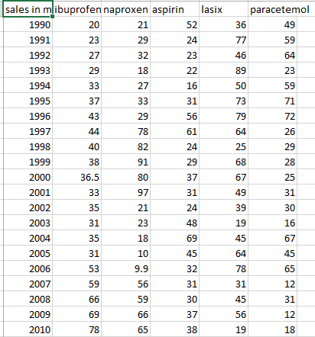

Table1: Twenty year sales record of branded fever medicines

This allows the User to select the drug and decide based on its contents and its market share. The Fig2 shows the market share of the medicine over last two decades. We have shown this on line graph on our website as shown in Fig4 for ease of user.

The user also gets a chance to know if he/she is allergic to a particular chemical composition and to select another drug with lower content of it.

This excel sheet shows the content of each medicine in grams in the form of a excel sheet. The graphical representation of the contents is available on our website and the example of it is shown in Fig3.

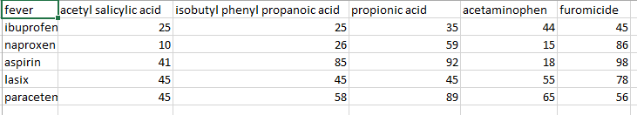

Table2: Chemical Composition of branded fever medicines

This increases the efficiency of the health care system as it provides a detailed description of the drug during various times of the year.

The user can also check the chemical composition and get to know more about the drug and its composition.

This system is not intended to replace the doctor but to enlighten the user about the drug and the user should not take medicines just on the basis of the site but after the prescription of the doctor.

This system intends to not only increase the morale of the user at the same time increase knowledge of the user.

1. **RESULT**

In general the problem of misuse increases as we go higher up in the knowledge field but the relevancy and credibility of the reviews also increases. Likewise when we go to the lowest knowledge field, patients the misuse is more difficult as the users are greater in number but the credibility of reviews is significantly lesser.

Also the amount of misuse is inversely proportional to the no of users of the system. If the no of user are more, the lesser percent can be faked and a lot or near impossible effort we be necessary to significantly alter the results. While having lesser could lead to vested interest manipulating the public opinion.

Hence a peer-to-peer review system could add much more transparency in the process of recommending a branded medicine for a generic one. It could also increase the knowledge of some

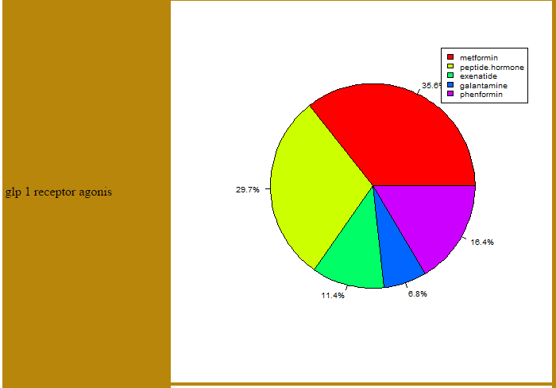

Fig3: The pie chart representation of Chemical Composition of branded fever medicines

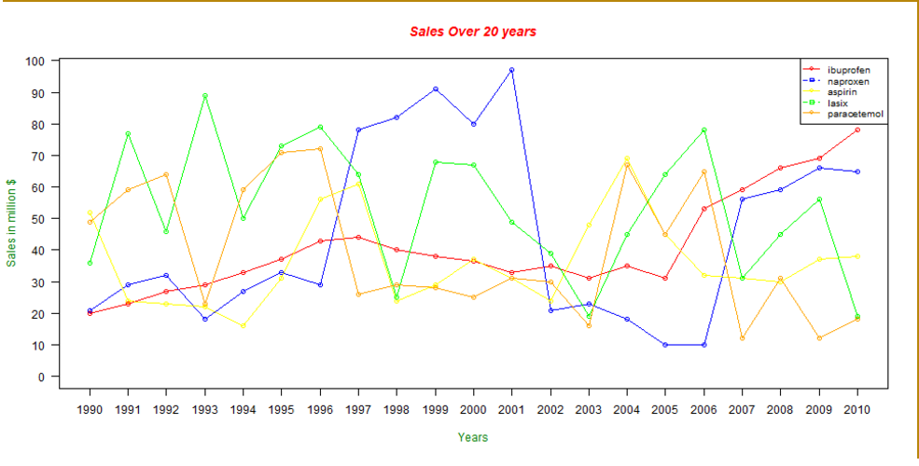

Fig4: the line graph representation of twenty year sales record of branded fever medicines

Side-effects of branded medicines often forgotten or covered up. It could also help rate the effectiveness of different branded medicines against a particular disease.

1. **CONCLUSION**

The project hopes to help patients to choose the best branded medicine for a generic one hence the name “generic to branded”. We have created a platform for peer-to-peer interaction to choose the best branded medicine in the eased possible way consists of only a few clicks. This project is made serve as test tool for this idea which could then be implemented in a big way. From experiences of many patients even the medical industry and doctors could gather an idea of which medicines are better and this could serve as rating for medicine quality across the board. This data will not only be useful for the patients but also medicine industry which can use it to find defects in their product and judge the customer mood.

If successful it can be extended to store the number of times customers search for which medicine providing a value tool to rate the medicine’s popularity and unpopularity and judge the required amount of marketing.

**REFERENCES**

1. Eysenbach G, Powell J, Englesakis M, Rizo C, Stern A. Health related virtual communities and electronic support groups: systematic review of the effects of online peer to peer interactions. Bmj. 2004 May 13;328(7449):1166.
2. Goldman RL. The reliability of peer assessments of quality of care. Jama. 1992 Feb 19;267(7):958-60.
3. Spier R. The history of the peer-review process. TRENDS in Biotechnology. 2002 Aug 1;20(8):357-8.
4. Richardson FM. Peer review of medical care. Medical Care. 1972 Jan 1;10(1):29-39.
5. Smith R. Peer review: reform or revolution?. BMJ: British Medical Journal. 1997 Sep 27;315(7111):759.
6. Margo CE. Peer and expert opinion and the reliability of implicit case review. Ophthalmology. 2002 Mar 31;109(3):614-8.
7. American Pharmacists Association, National Association of Chain Drug Stores Foundation. Medication Therapy Management in community pharmacy practice: core elements of an MTM service (version 1.0). Journal of the American Pharmacists Association: JAPhA. 2005;45(5):573.